SERAP Online – Uploading Reports

Open up SERAP online in a web browser and click on “Log in” box and choose “Researcher login”.
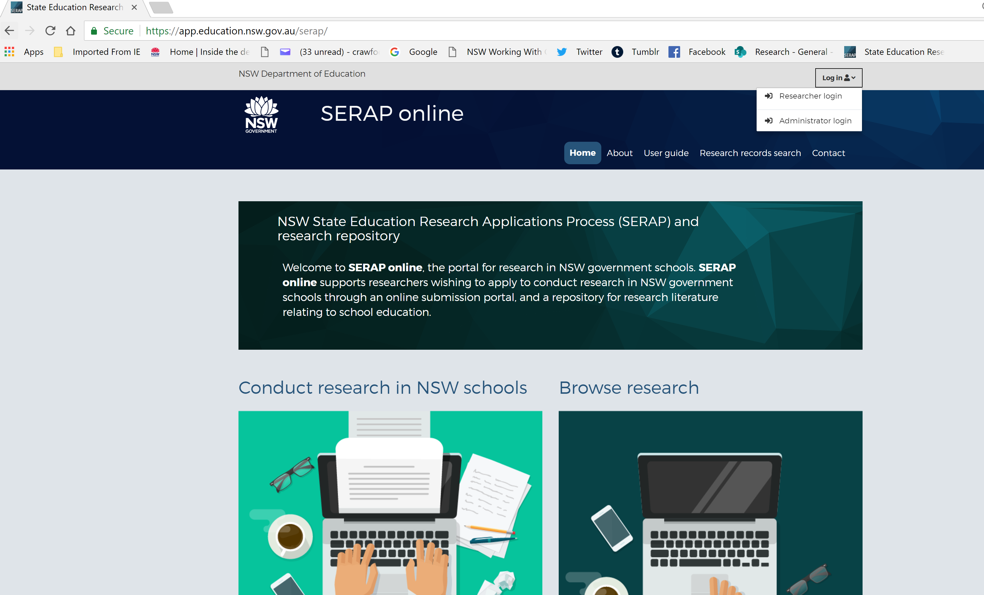

This will bring you to the Researcher log in page.
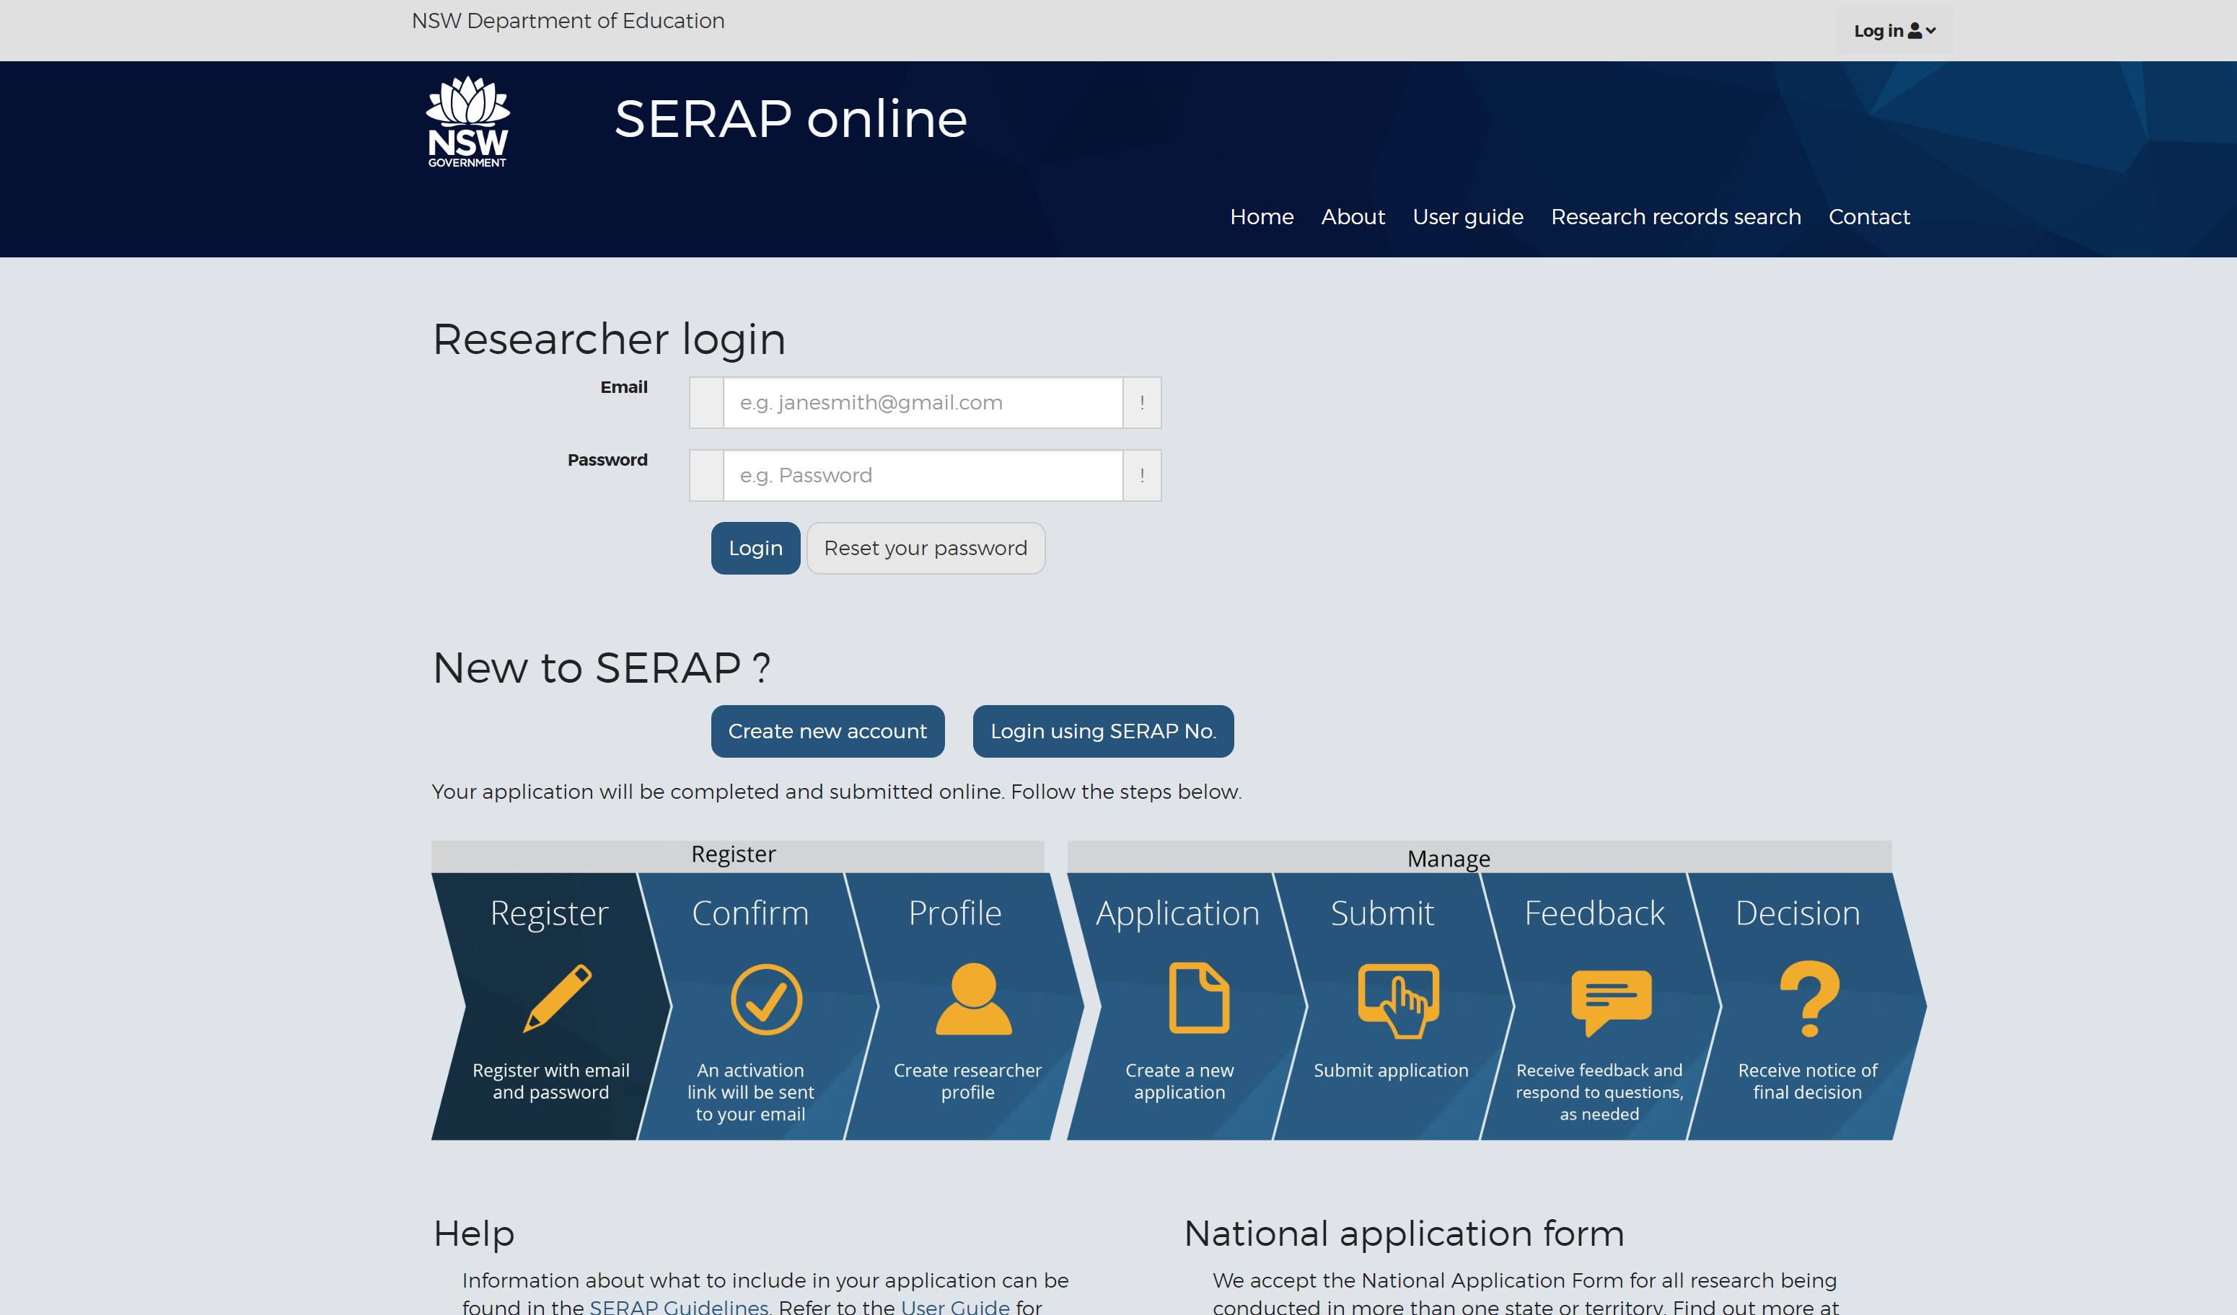

Enter your Researcher email and password and then click the BLUE “login” button below it.
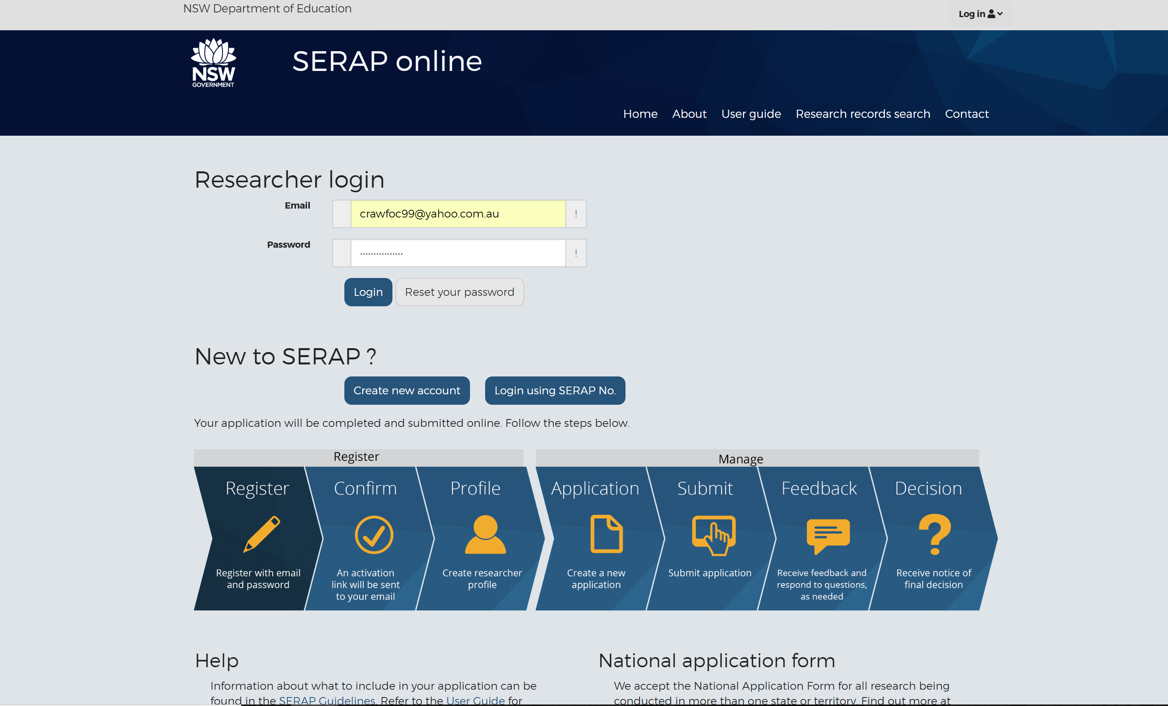

This brings you to the Researcher Dashboard. Click on the “Browse my SERAPs” section to open your SERAP application/s.
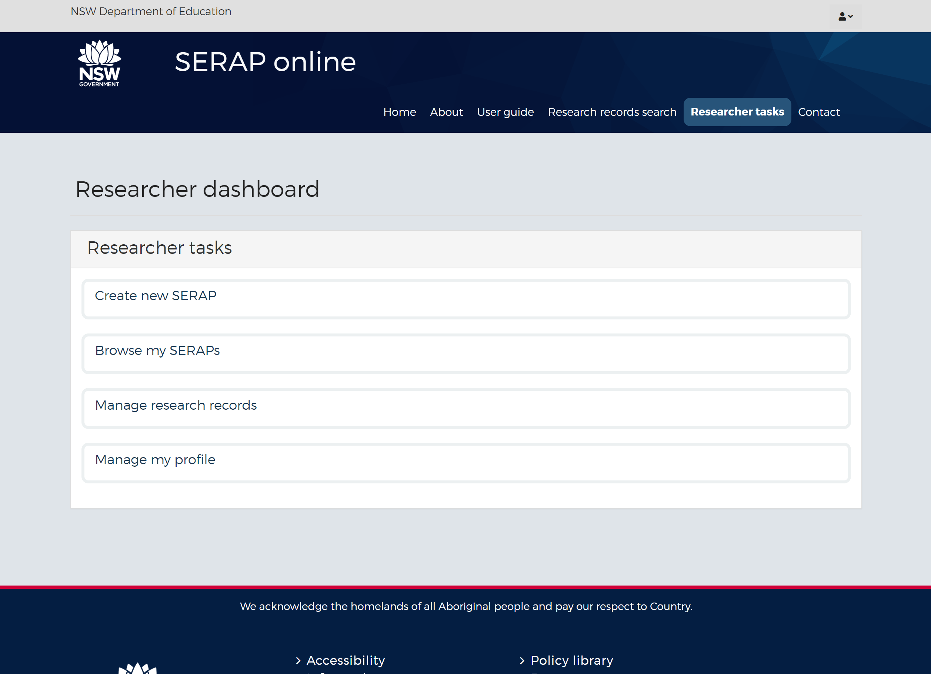
Note the SERAP number you want to add a report to. In this case, I want to add a report for SERAP 2015046.
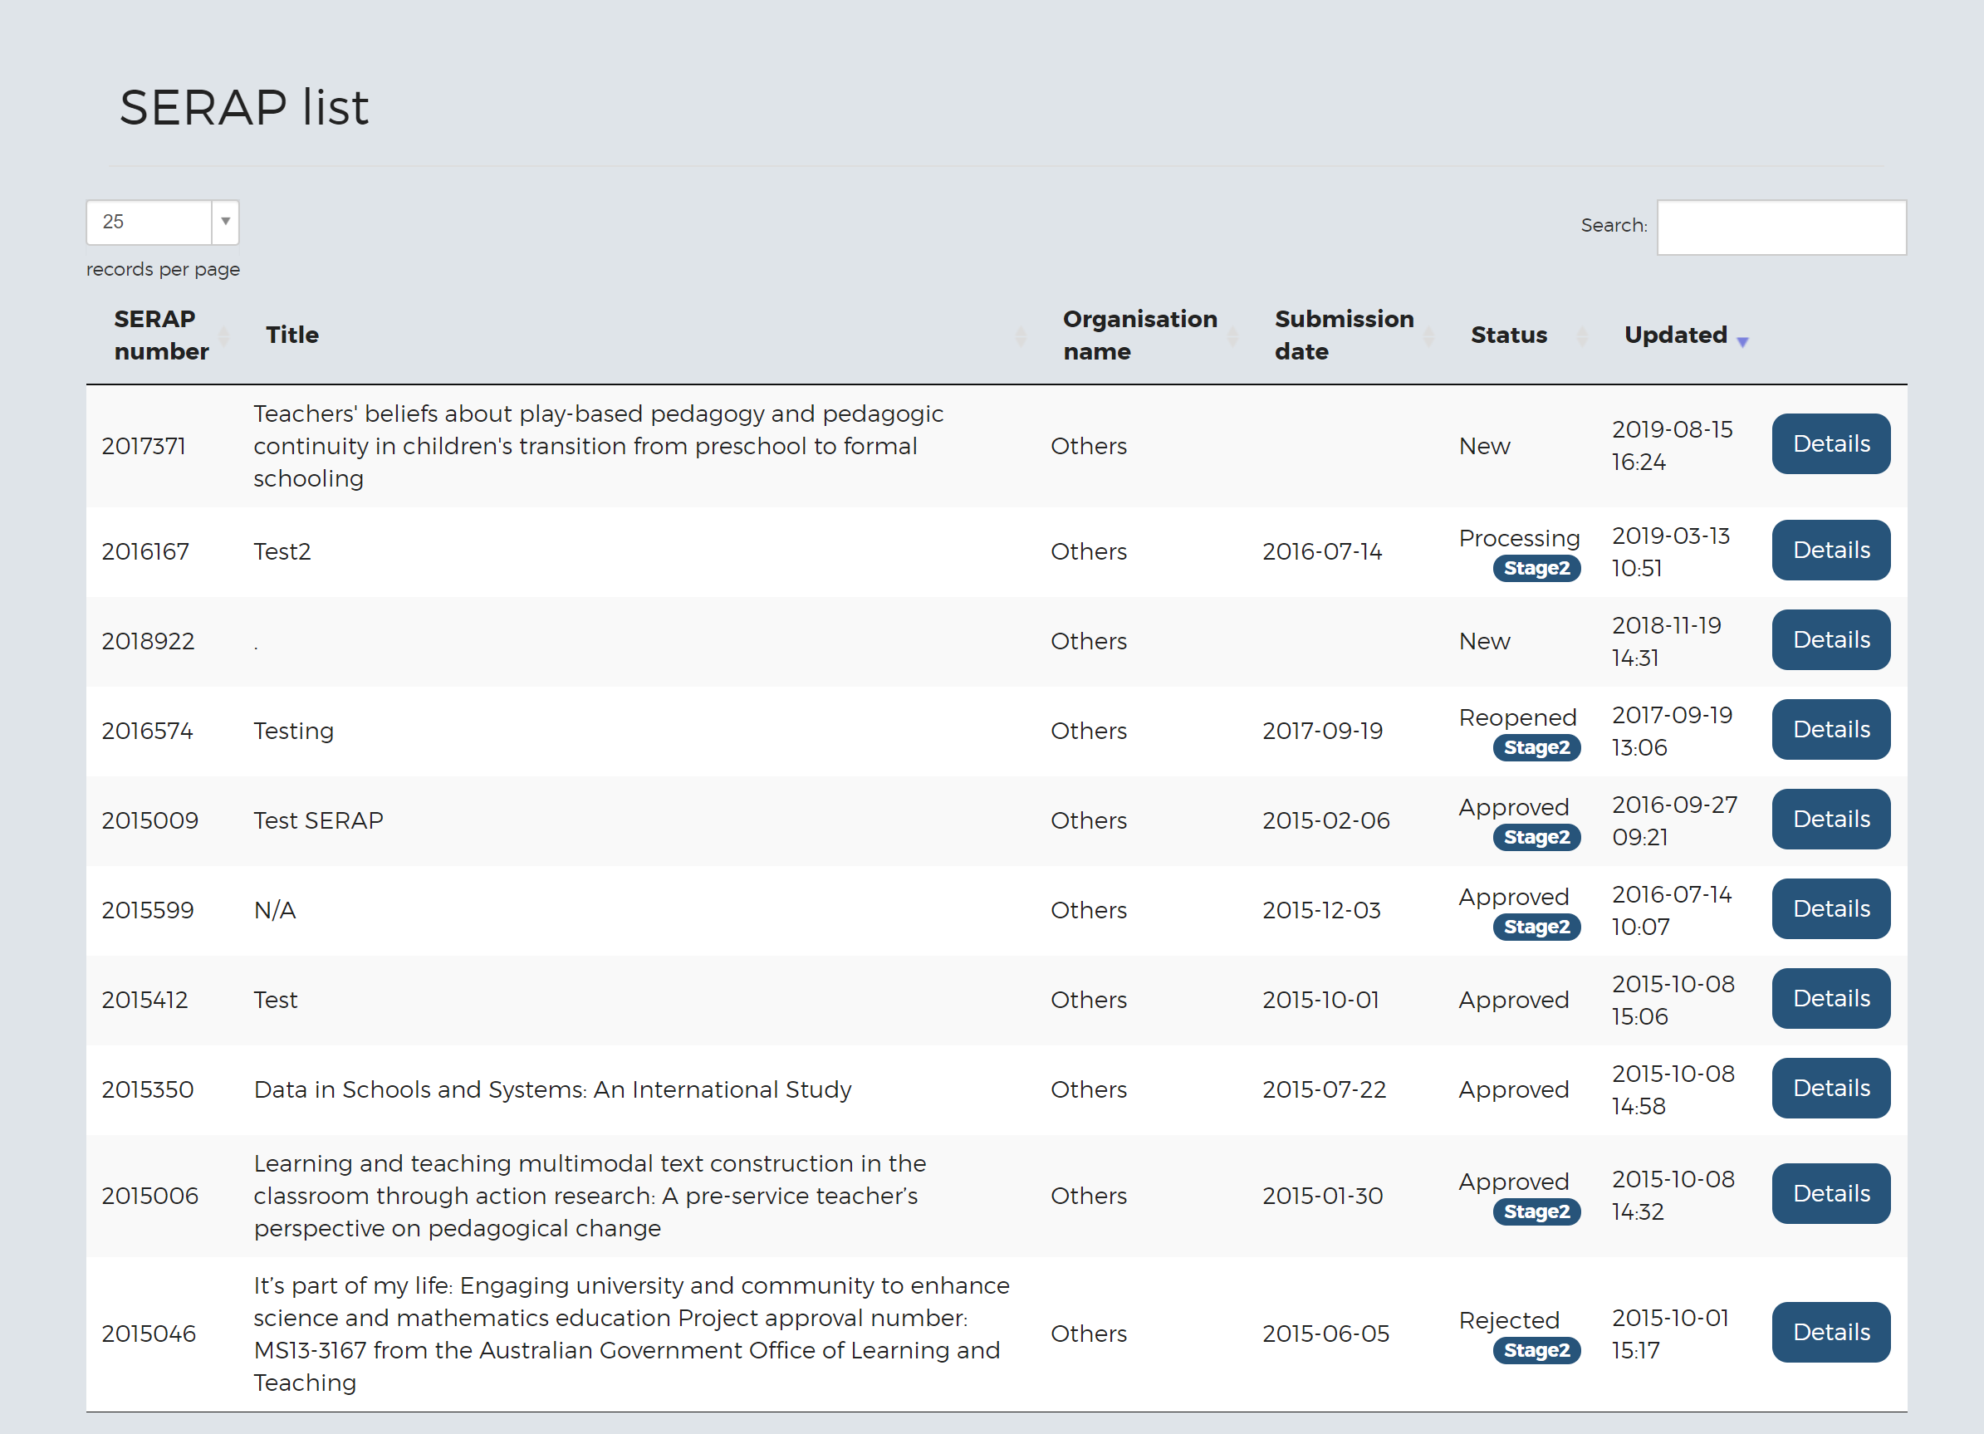
Click on the “Researcher Tasks” button once again to go to the main Researcher dashboard.
Then click on the “Manage research records” button to open up the next page where you can create a report profile.
You can see from this page you can search for reports by Keyword, Author, Category (shows how many reports are in the repository), SERAP number and published dates from and to as well as featured reports. Please note that there is a disclaimer stating that the Reports have been submitted freely to the NSW Department of Education and there are also links to record repositories in other states as well as AARE and ACER.
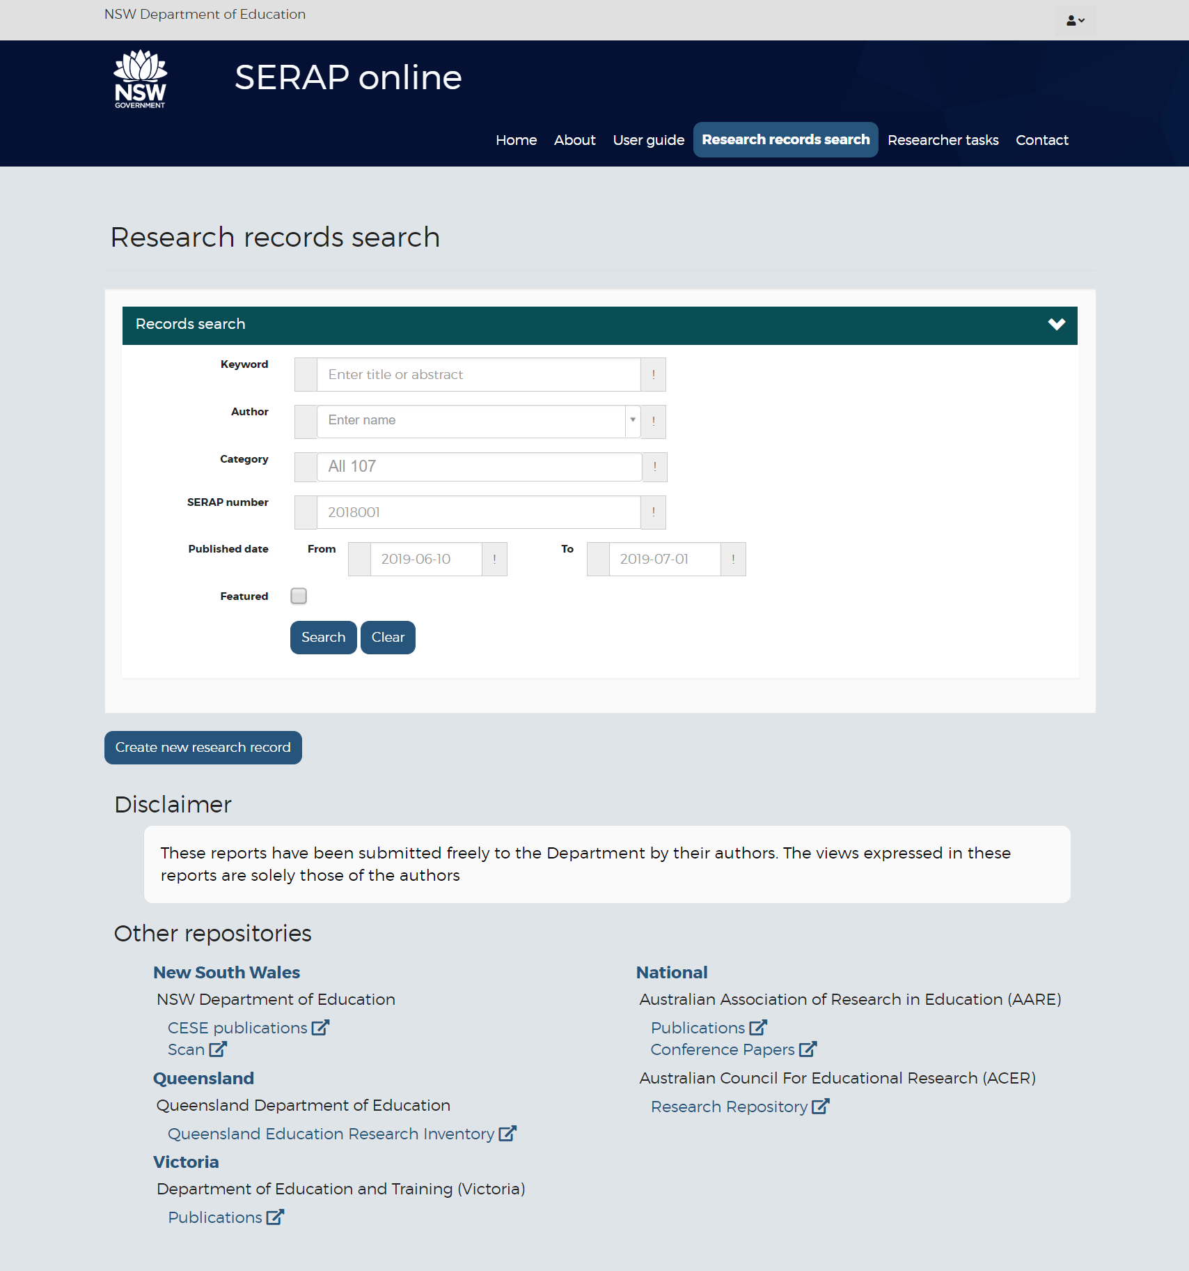

To create a new record, click on the “Create new research record” button
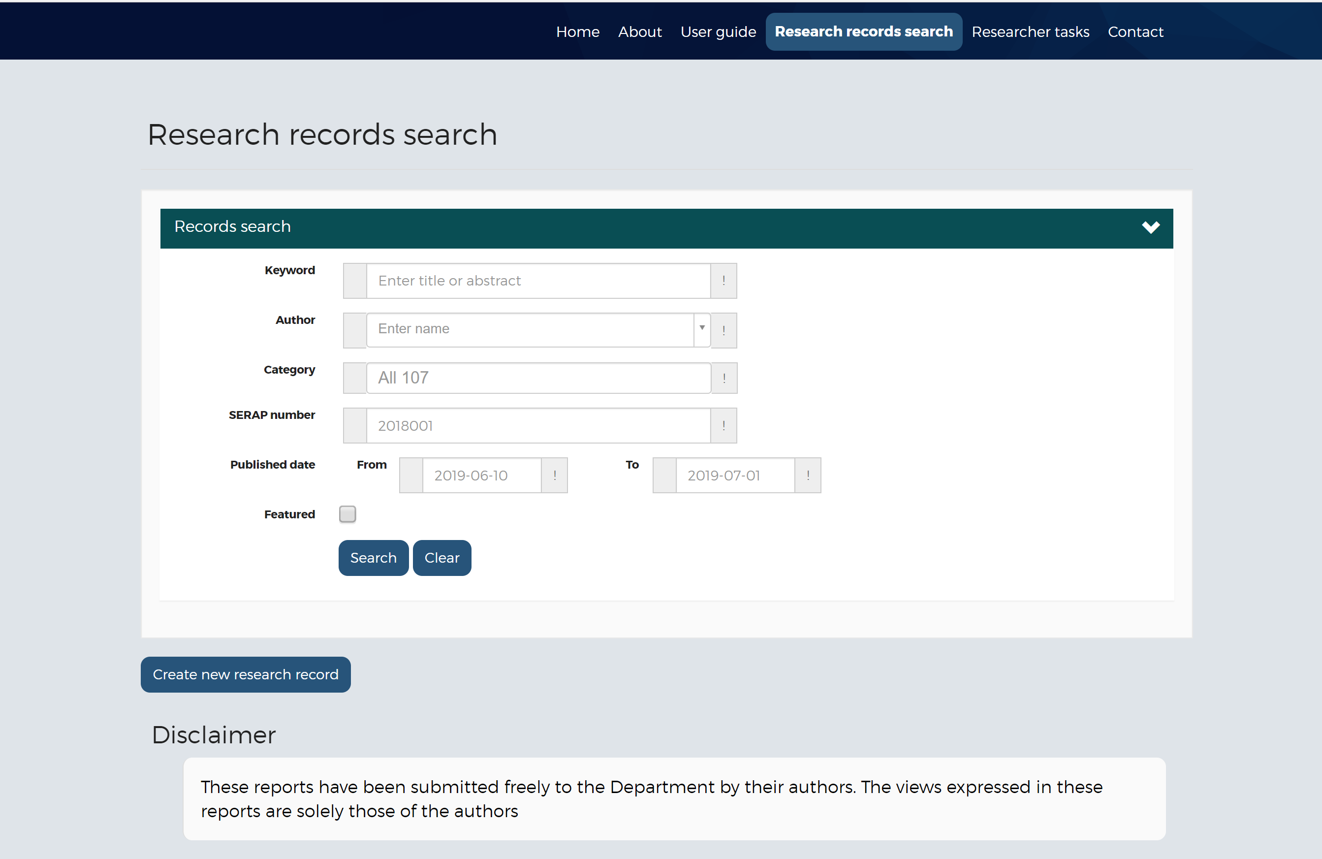

This will bring up the Create research record page where you can enter the type of report you want
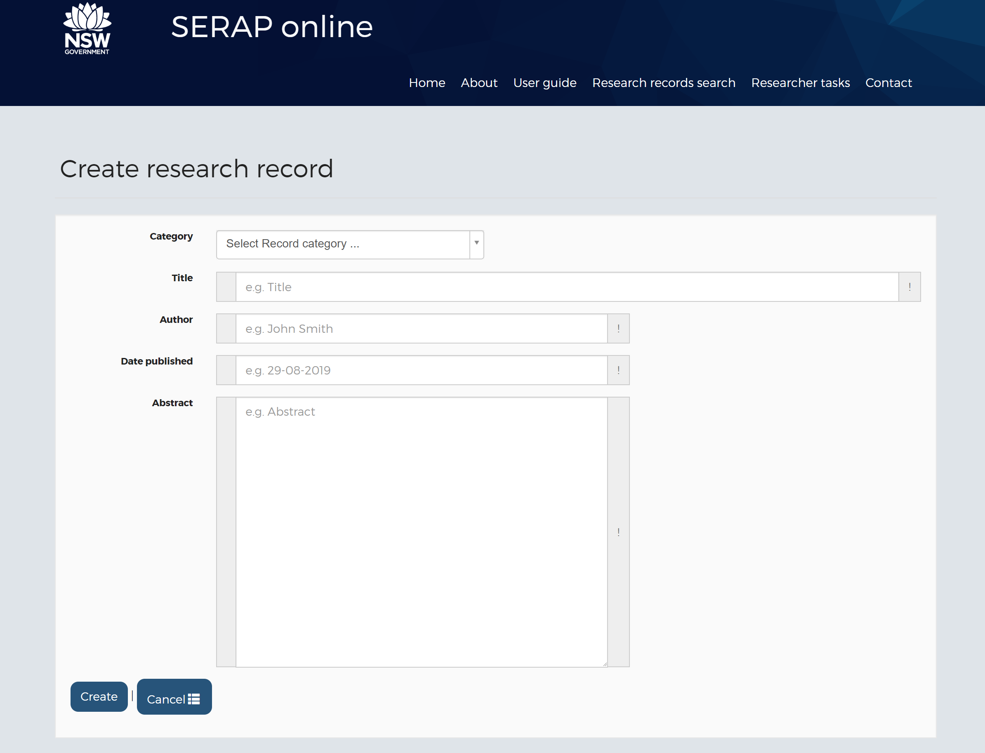

Click on the “Category” drop down list to see what types of reports can be uploaded. In this case, it will be a SERAP Report
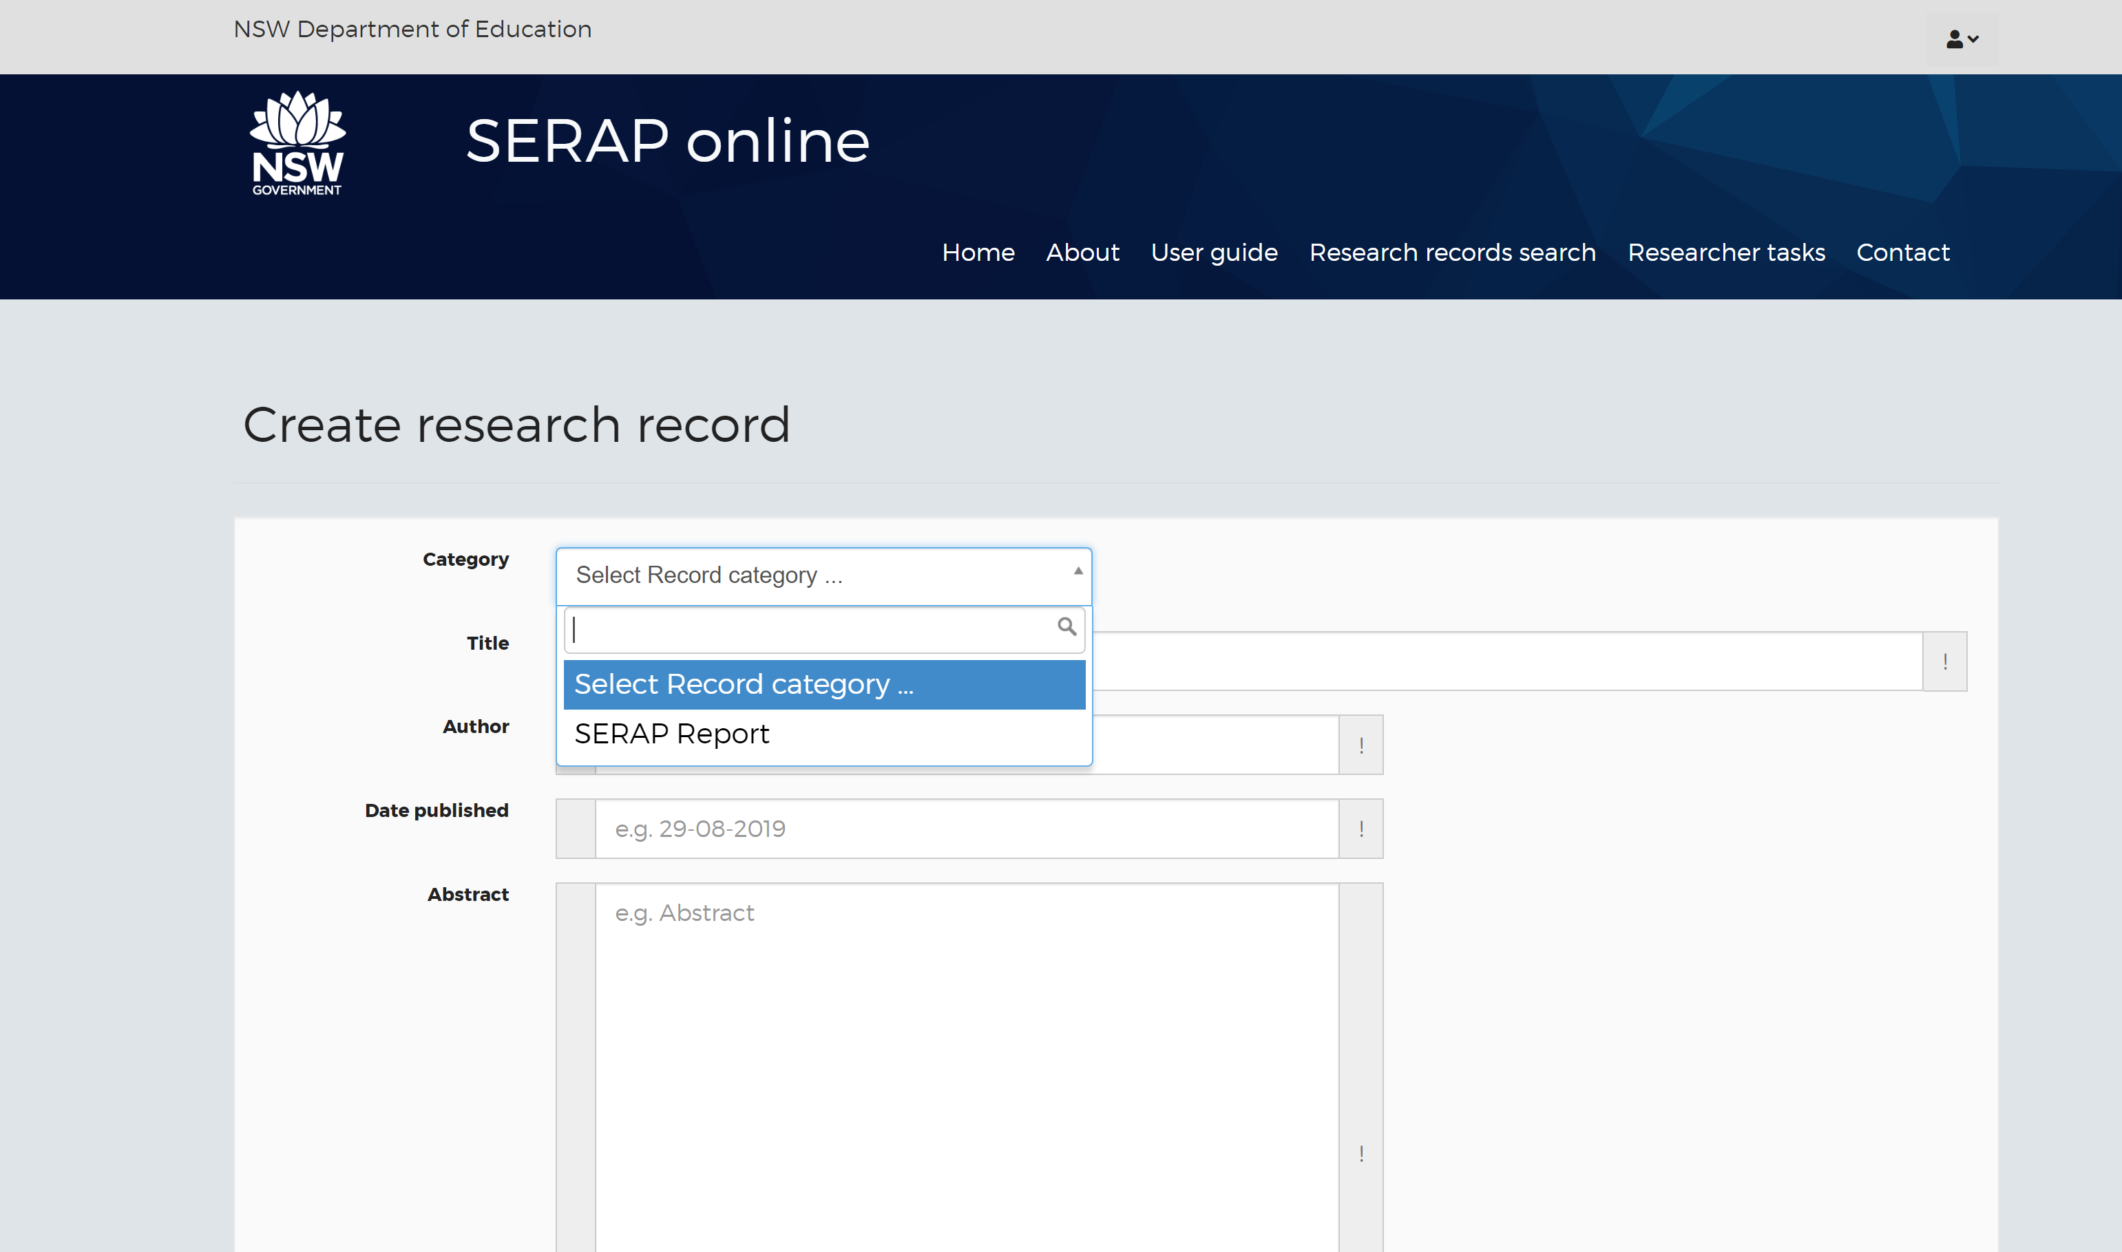

Next enter the SERAP number
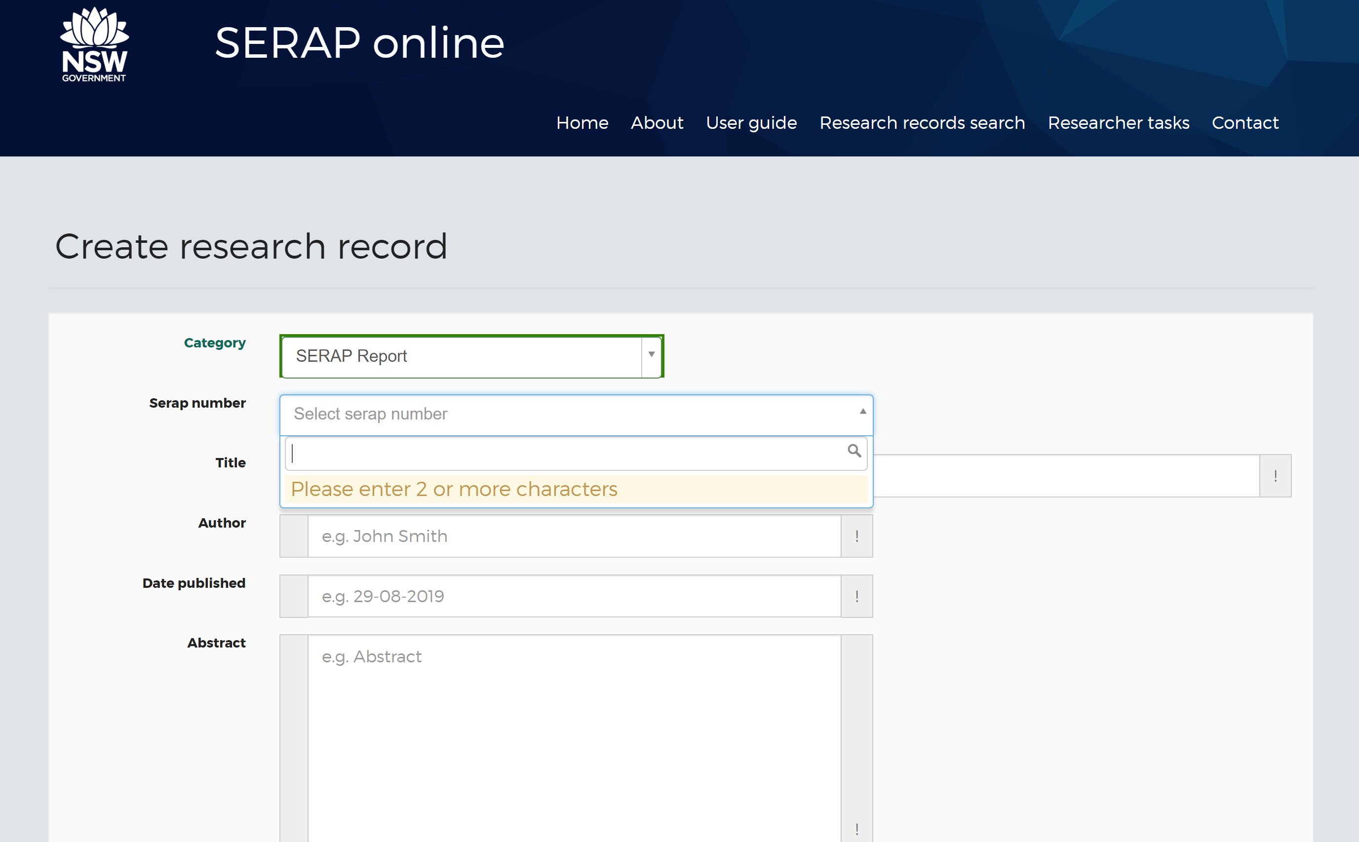

As you start typing, the list of your SERAP applications will come up listed in SERAP number order for approved SERAPs only
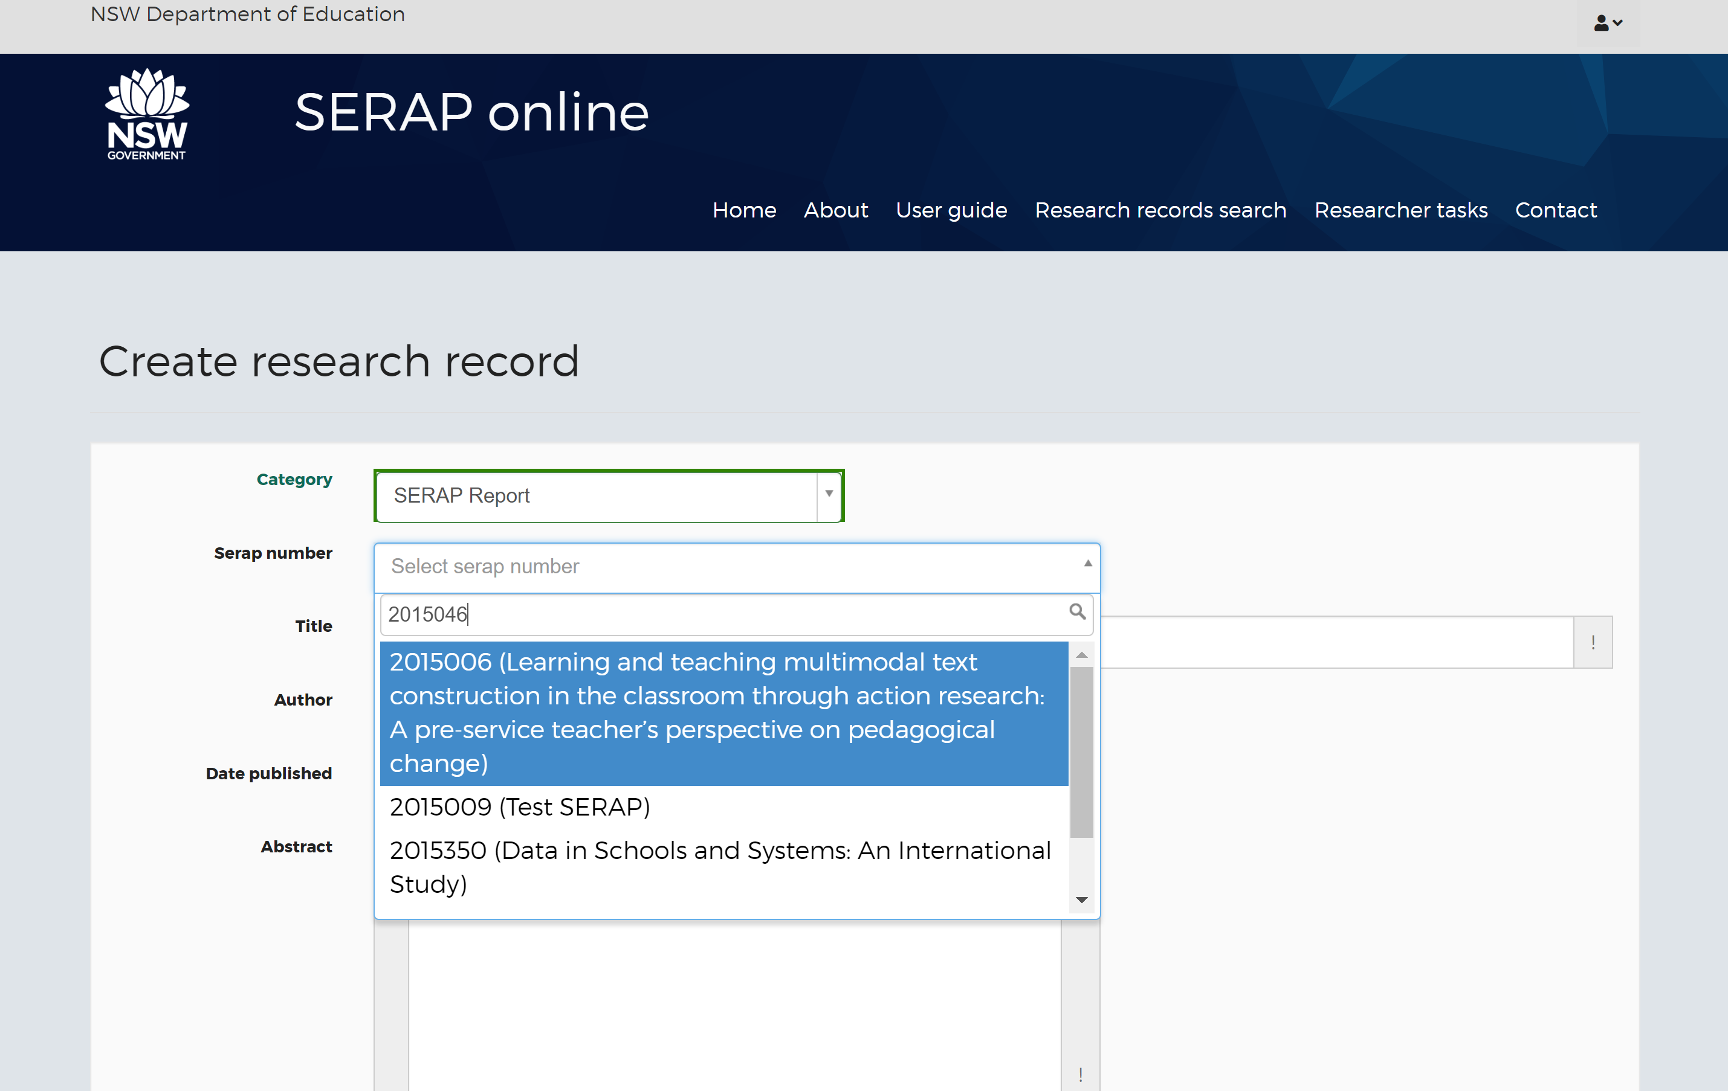
Scroll down until you find the SERAP you’re looking for then click on the blue highlighted section to select it

Then you can enter the title, author, date published and abstract details, when you’ve finished, click the BLUE “Create” button
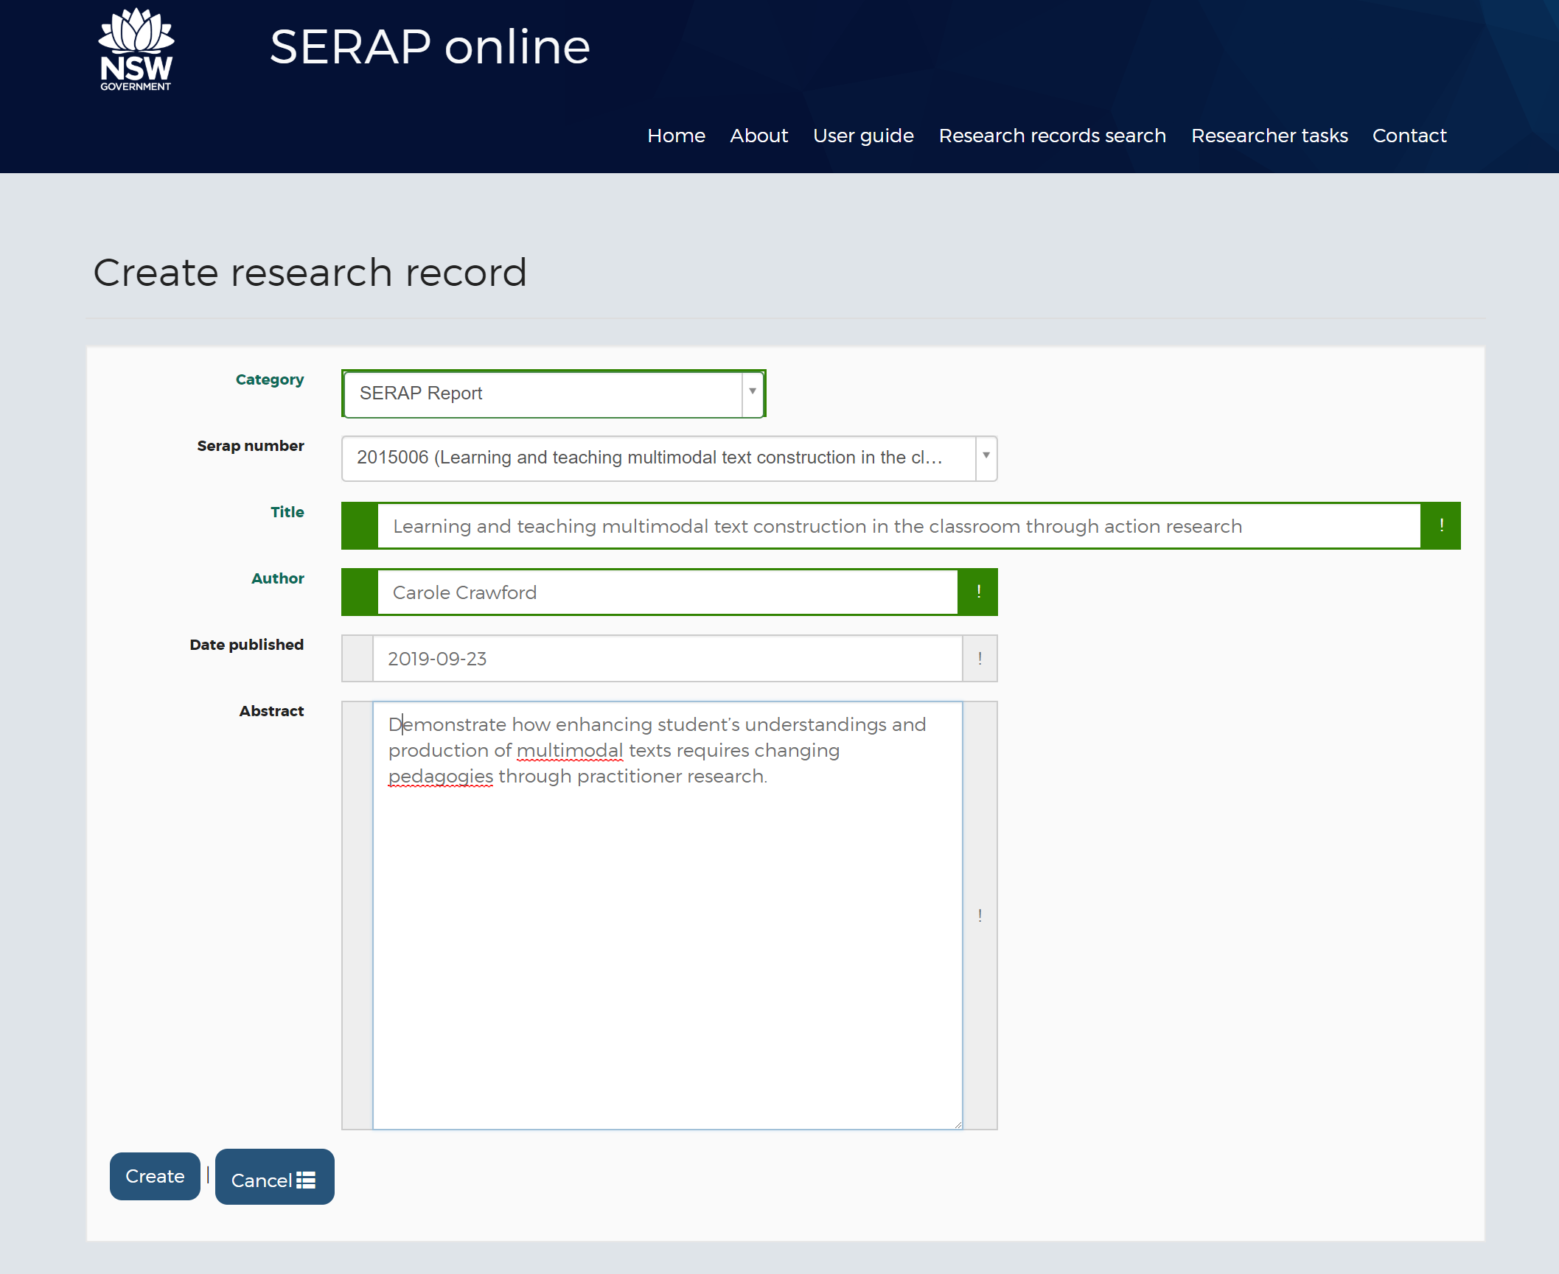

Now you can see that your research record is listed as “Status: Draft”
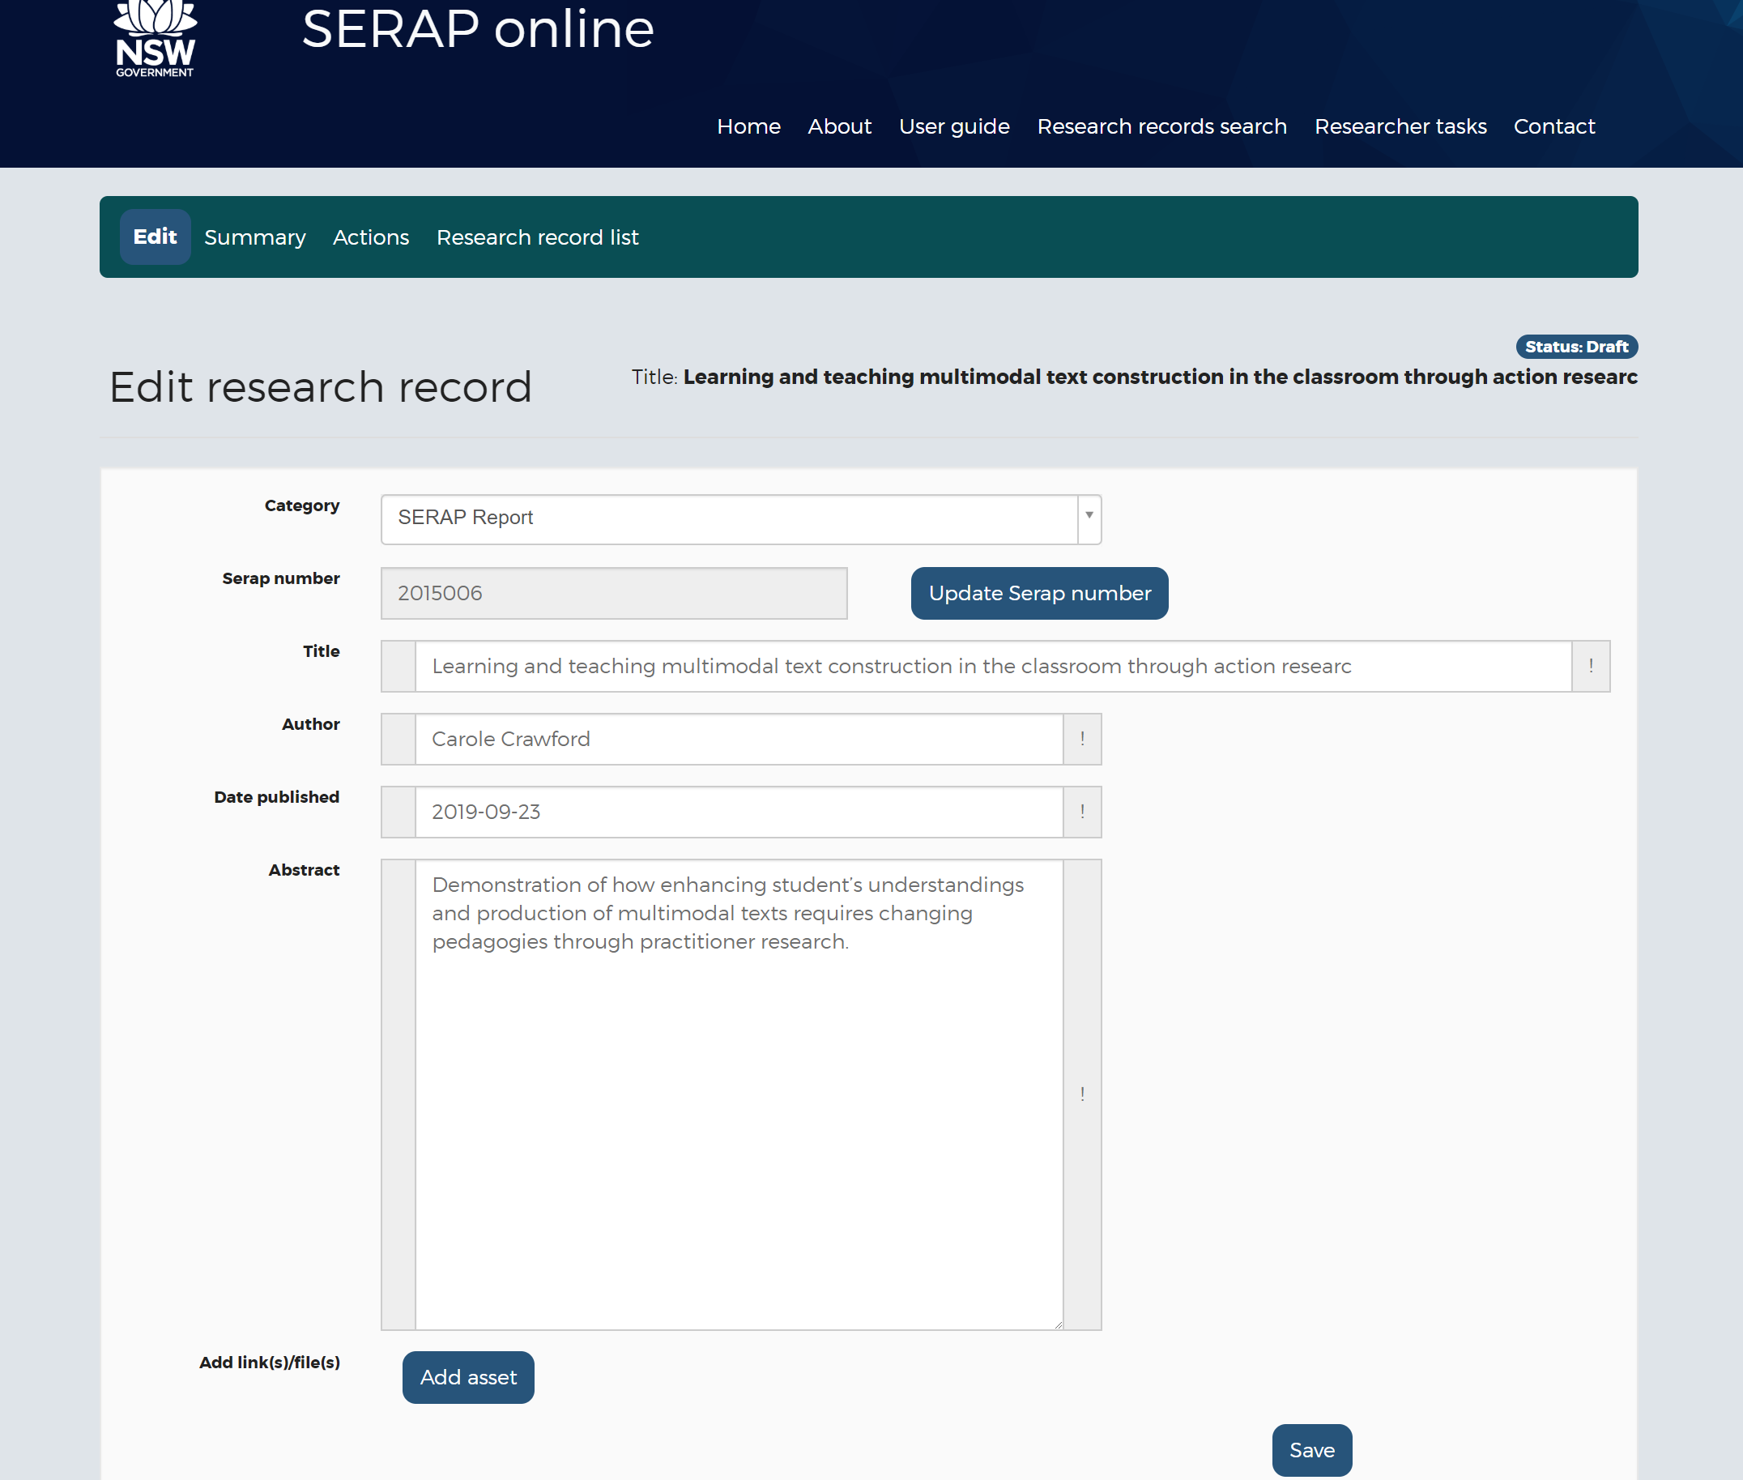

Now you have to add your SERAP report to the entry by clicking on the Add asset tab

This will open up pop up menu where you can enter the type of report and you can add the Title, asset type (either file or URL link), select file (in Word or PDF format only). Please note that there is a maximum of 20MB allowed for uploading documents. You can also click on the box if the report is accessible (with link to accessibility guidelines) and finally you can add a description of the report
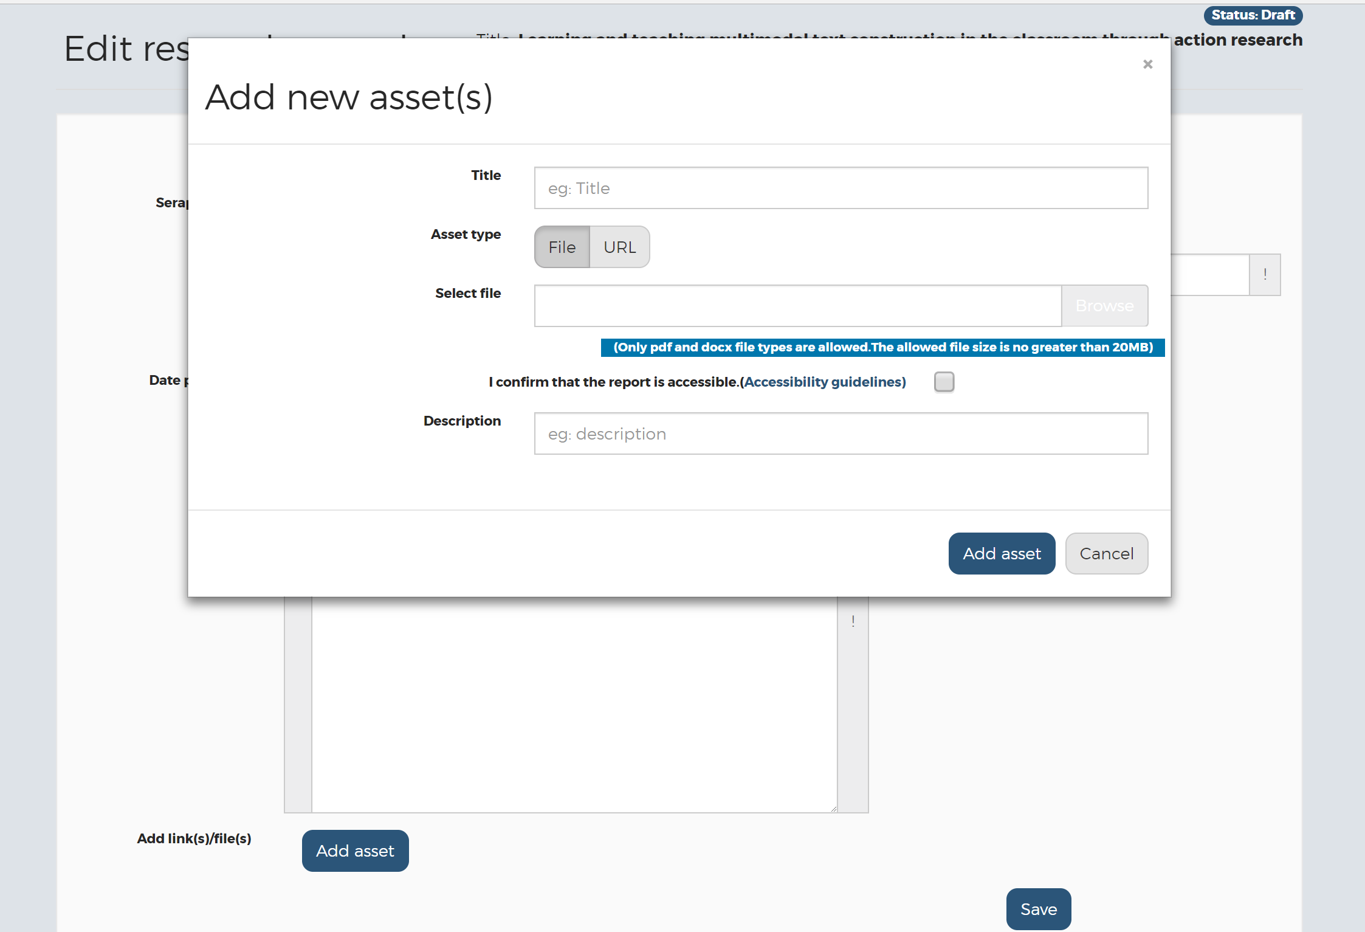

When you’re ready, click on Add asset button to load
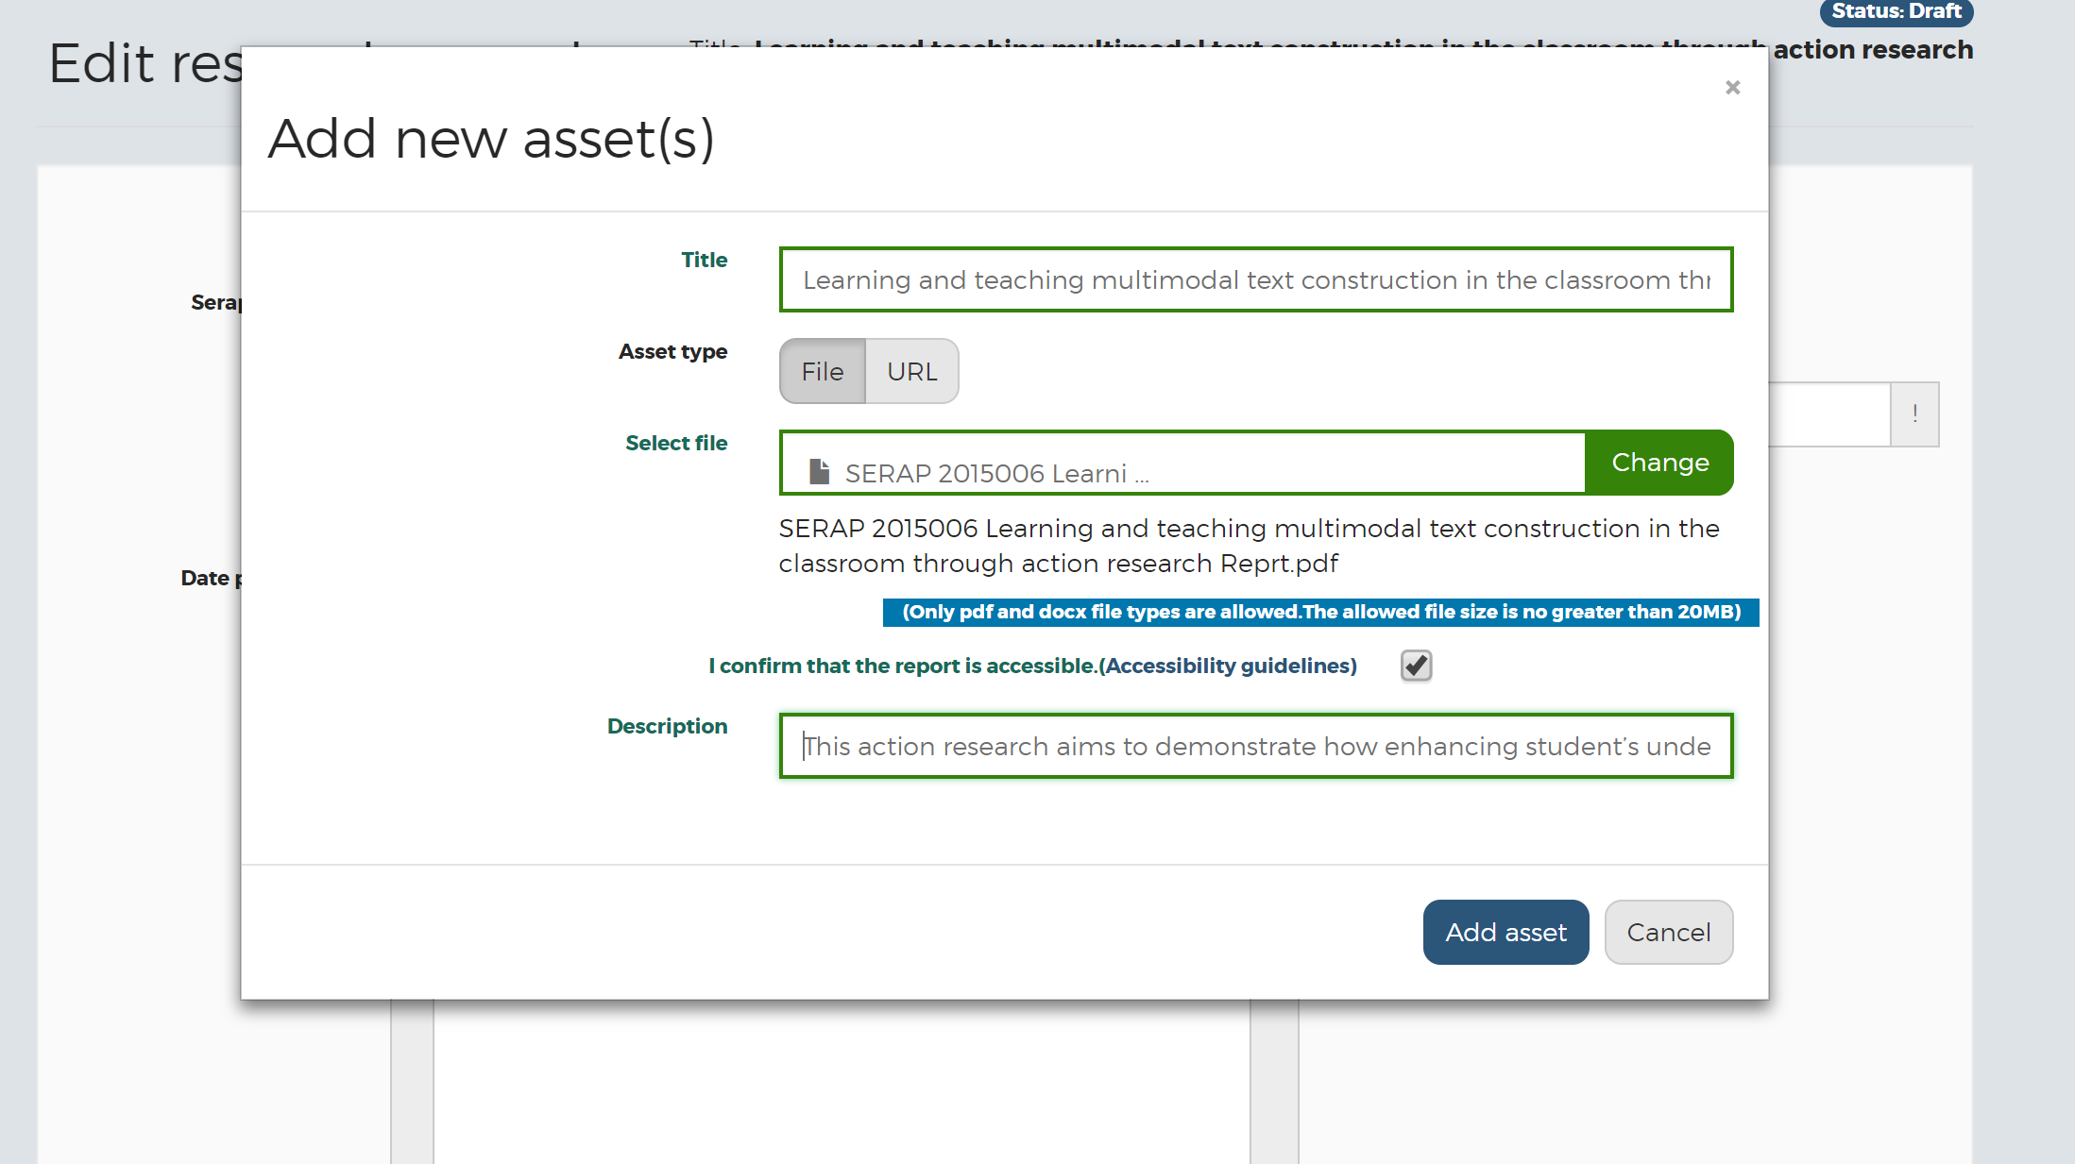
You now can see that you have an asset uploaded to the SERAP report. You can delete the report if you’ve uploaded the wrong one
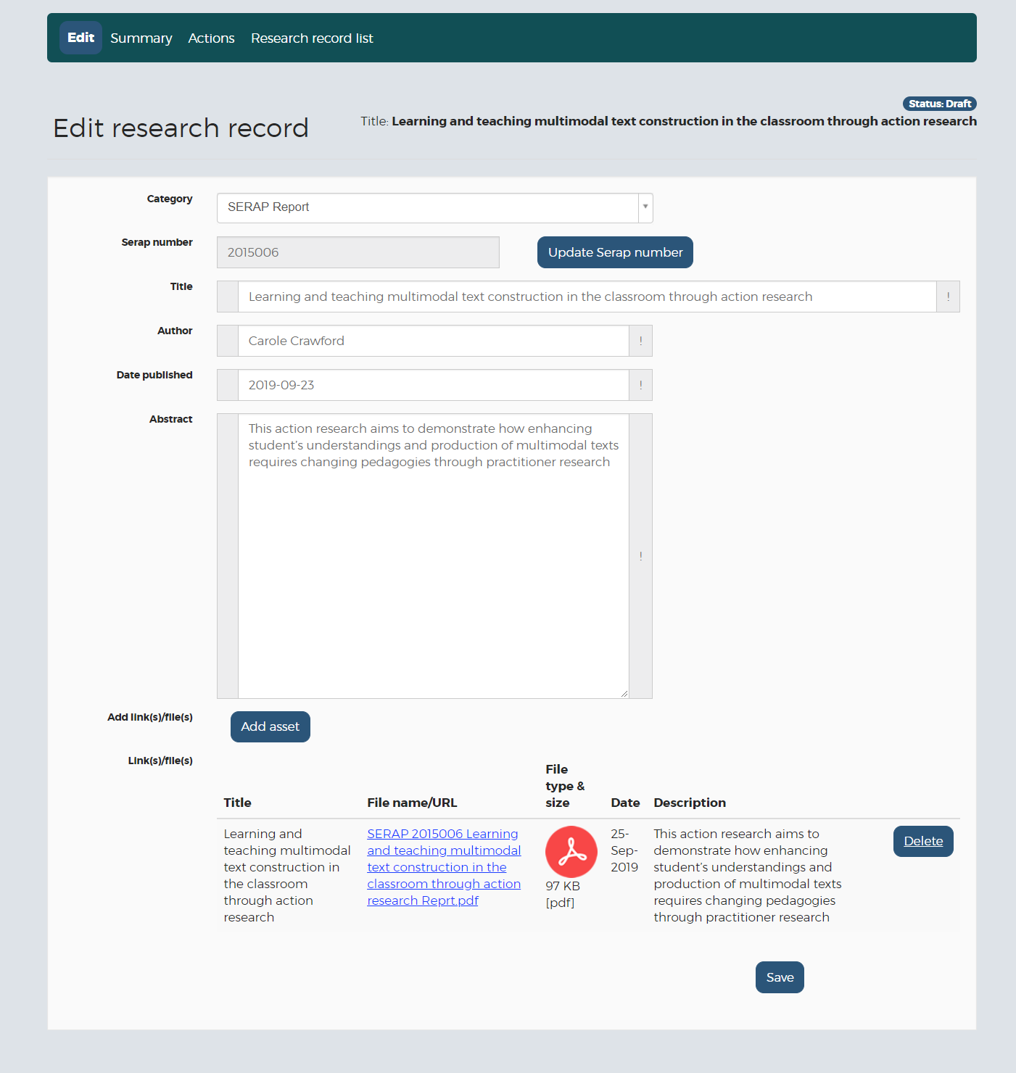

When you’re ready, click the Save button

Click on the Summary button in the top left bar to see your report added
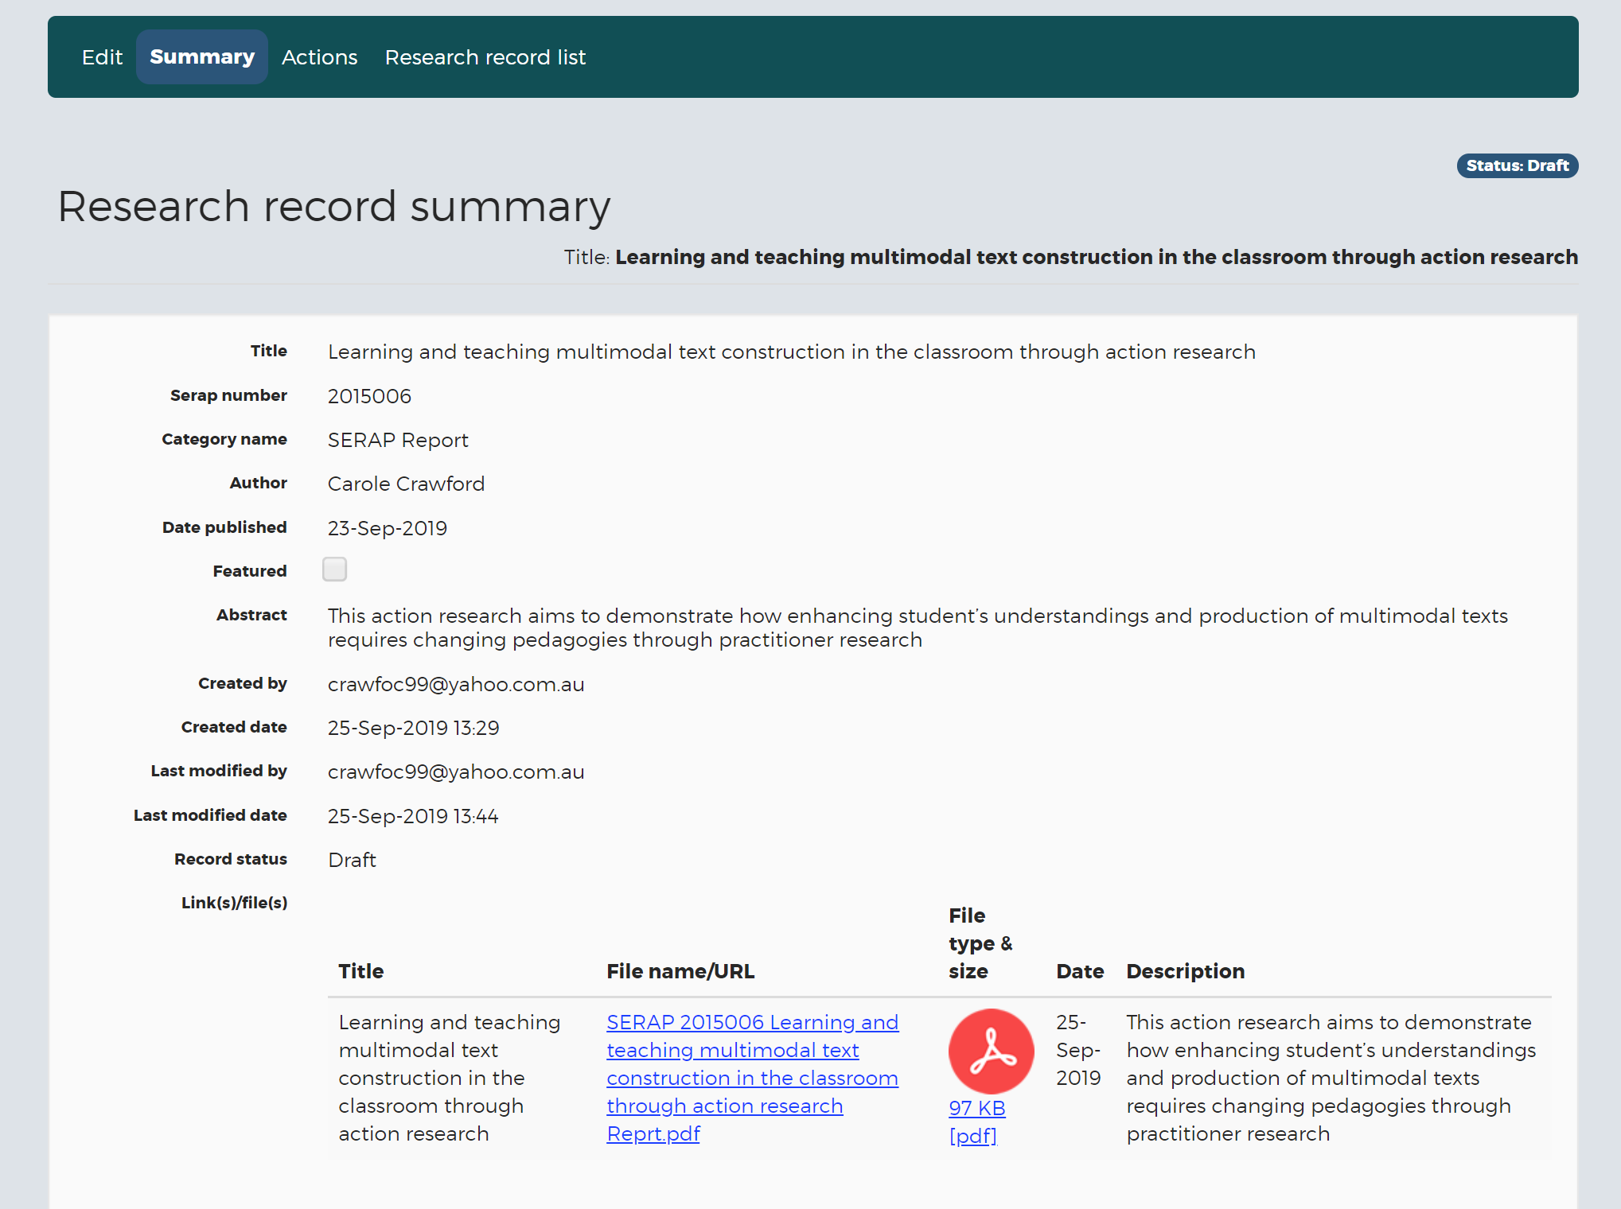

Next click on the Actions button in the top left bar to submit your report or delete it.
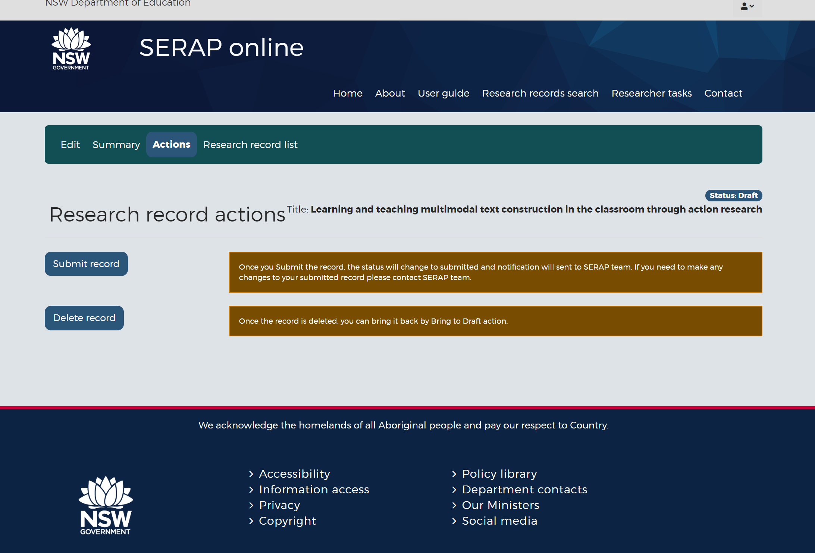
If you click delete record, you will need to go back and start the uploading process

If you click Submit record, you will get a further pop up box to make sure you’re ready to submit your report in SERAP online
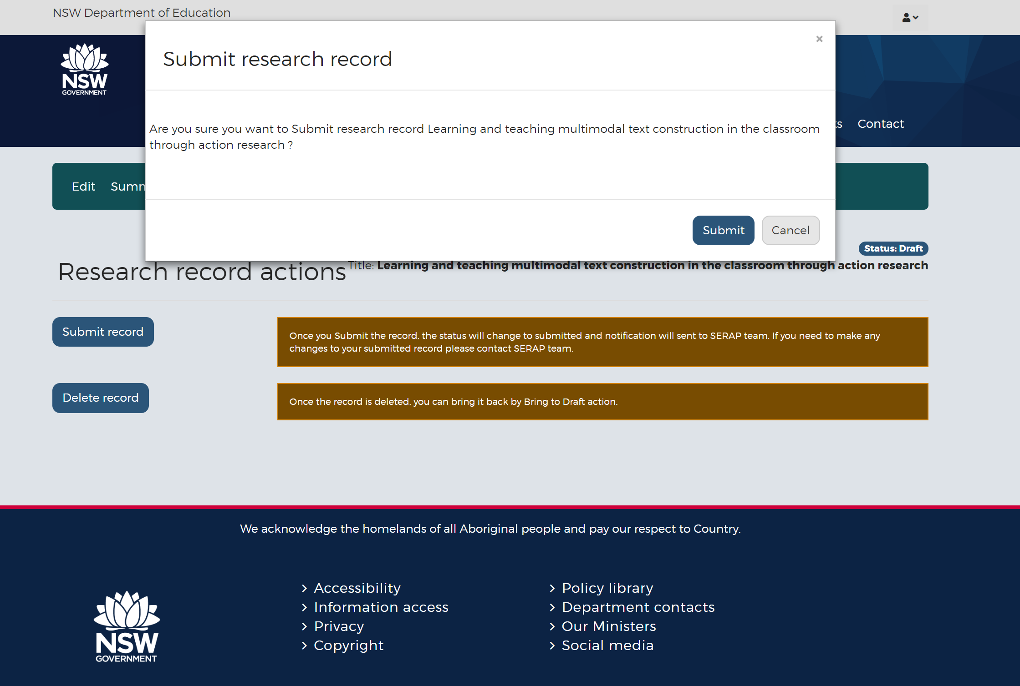

If you click the Submit button the status will change to “Submitted”
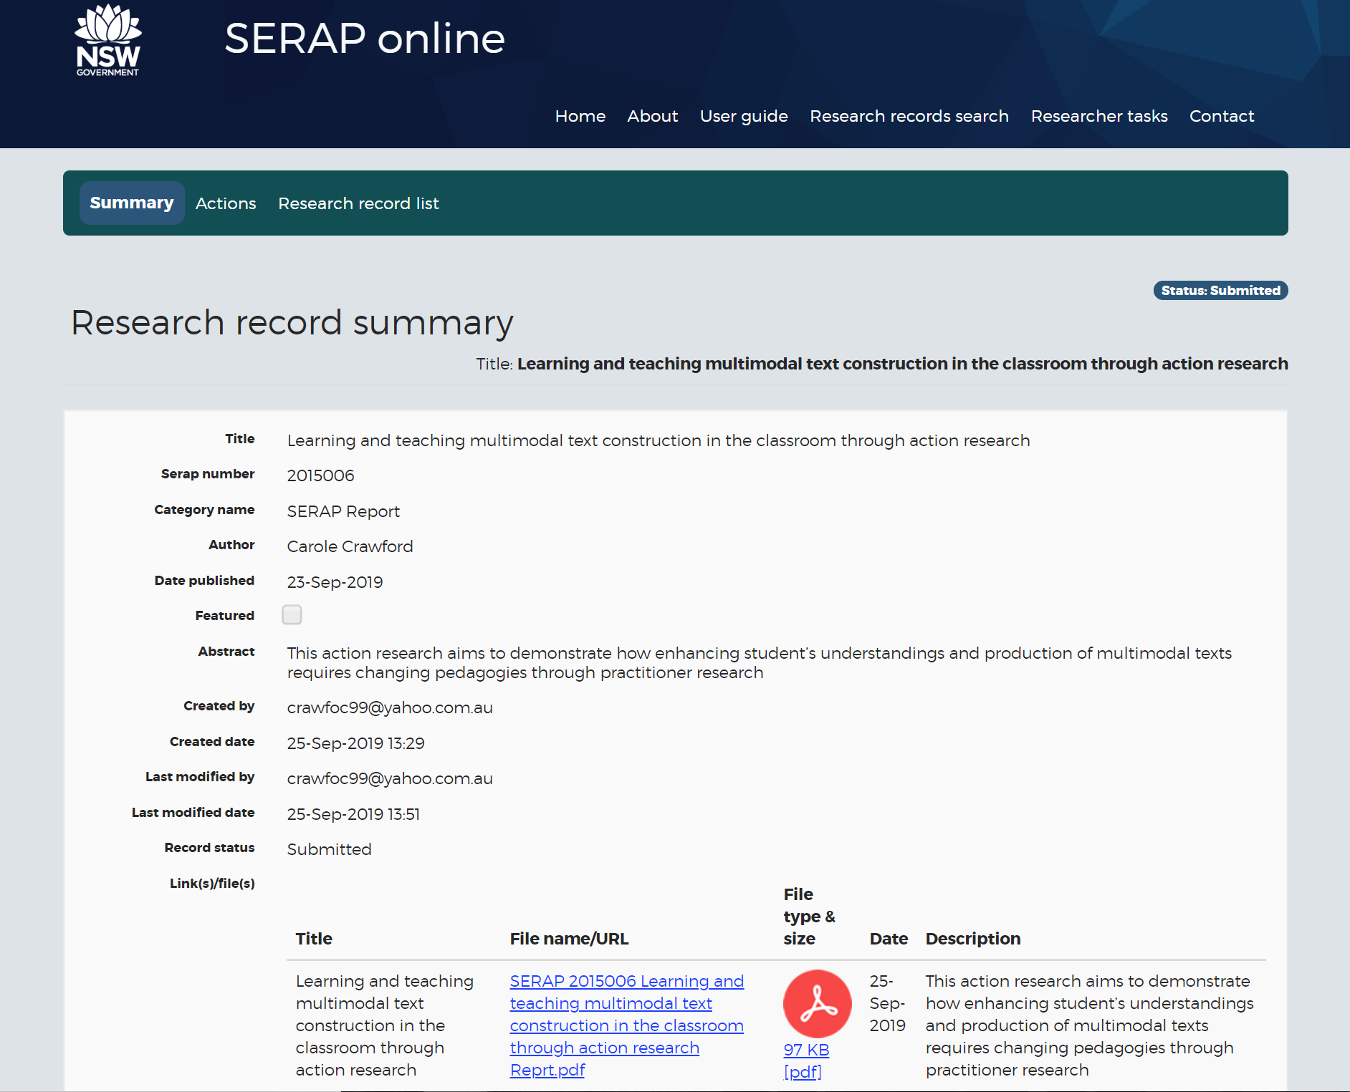
An email notification of the uploaded report will be received in the SERAP inbox where the SERAP moderators will decide whether to publish the report
